LeDeR report (easy read)

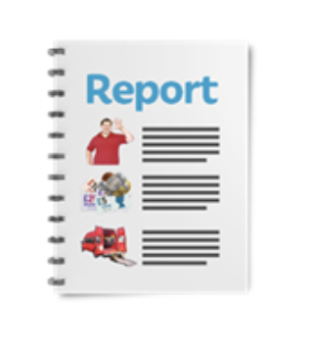 | This is the first report of the Learning Disabilities Death Review (LeDeR) programme for Nottingham and Nottinghamshire.  The report was written in April 2020.
 | It tells you about the deaths of people with learning disabilities. The deaths were checked in 2017, 2018 and 2019.
This report is about people who have died, who were special to their families and friends.
Thank you to all families who have taken part in the reviews.

The aims of the LeDeR programme are:
- To help improve health and social care services for people with learning disabilities.
- To stop people with learning disabilities dying too soon.

 | The LeDeR programme in Nottingham and Nottinghamshire has been told about the deaths of 167 people with learning disabilities since November 2017.
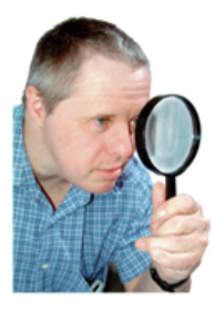 | 152 have had an initial review completed (about 9 out of every 10 cases).
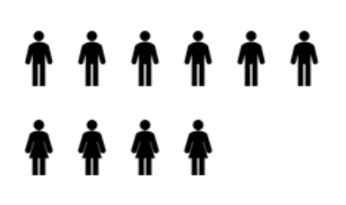 | 6 out of every 10 of the people who died were male.  4 out of every 10 of the people who died were female.
 | We have found 9 out of 10 people with a learning disability in Nottingham and Nottinghamshire have received satisfactory, good or excellent care
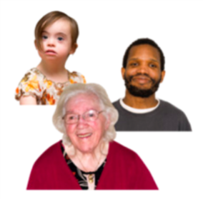 | The average age at death for people with a learning disability in Nottingham and Nottinghamshire was 62 years old.
 | There were more deaths in Nottingham and Nottinghamshire than we expected.
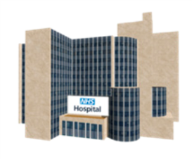 | More people died in hospital than we expected.
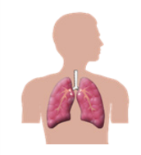  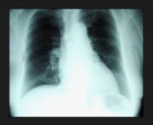  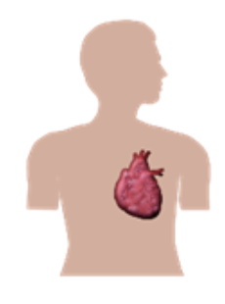 | The four most common causes of death were:  1. Pneumonia.  This is an infection in your lungs caused by bugs called ‘bacteria’.  2. Aspiration pneumonia.  This is an infection in your lungs caused by food or drink going down ‘the wrong way’.  3. Cancer.  This is a disease which can be in any part of your body.  4. Cardiovascular.  This is a problem with your heart.
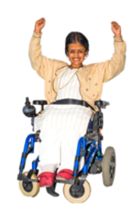  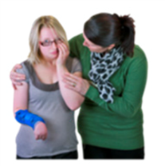 | We found several things kept being said at our reviews. These were:  1. We need to try to involve family members more in the reviews.  2. Care needs to be based more around the needs of the individual person (making ‘reasonable adjustments’).  3. Staff who care for people with learning disabilities need more help with training and skills.  4. It is important that people with learning disabilities receive a health check every year.
 | We have learnt many things from our LeDeR reviews. We are writing an action plan to improve care and support for people with learning disabilities.
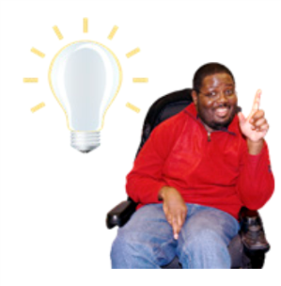 | What do you think? Are there things we could be doing better? Please let us know.

